**Zener diode as a voltage regulator**

**Introduction**

**Zener diode:** the Zener diode acts like a special kind of voltage regulator, know as shunt regulator. Any current that does not go to the load goes into the Zener, and Zener limits the voltage to its specified value.

**Objective**

Construct a working model of voltage regulator by using Zener diode

**Material required**

* Zener diode (8v)
* Battery (voltage source)
* Bread board
* Resistors(100kΩ,1kΩ)
* Voltmeter
* Wires

**Software:**

* Proteus

**Prerequisites**

* Zener diode has to be in reverse biased
* Current regulator resistor should be in series with Zener diode

**Procedure**

* We created a voltage regulator circuit on proteus software.
* For this we took a Zener diode of 8 volts in order to maintain the constant 8 volts as output.
* Placed Zener diode in series with current limiting resistor of 1kΩ and placed in parallel with load resistor of 100kΩ.
* In order to voltage supply attach the positive terminal of the battery with the negative terminal of the Zener diode and negative terminal of the battery with the positive terminal of the Zener diode.
* When the current started flowing through the circuit, we changed the supply voltage with every time and checked the output voltage of the circuit by using voltmeter.

**Out put**

|  |  |  |  |  |
| --- | --- | --- | --- | --- |
| **Applied voltage** | 9v | 11v | 13v | 14v |
| **Output voltage** | 8v | 8v | 8v | 8v |

**Proteus circuit diagram**

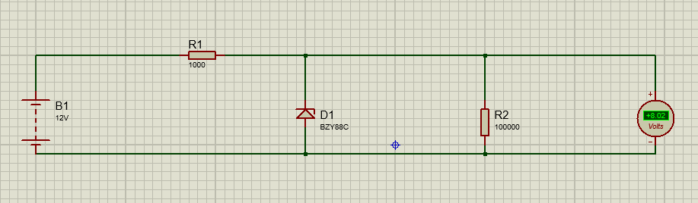

**Hardware circuit diagram**

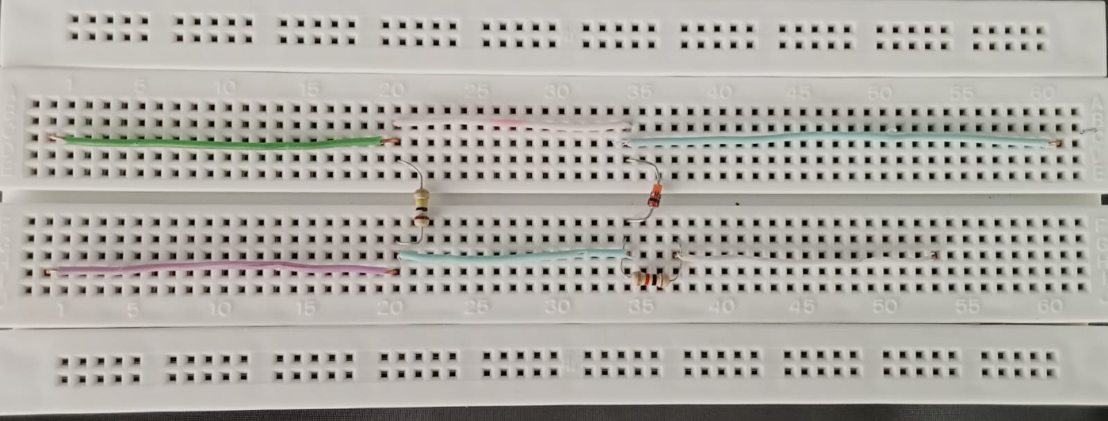

**Conclusion**

We learned that Zener diode word as a voltage regulator and give constant voltage by changing the source voltage.